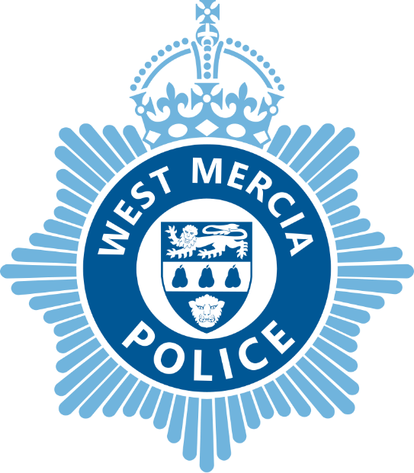

**Chief Constable**

**Force Information Pack**

**January 2025**

## General information

West Mercia is the fourth largest geographic police area in England and Wales, covering 7,428 square kilometres. Our communities cover three counties: Herefordshire, Shropshire (which includes Telford & Wrekin) and Worcestershire with more than 1.3 million people living in the areas we serve.

Whilst many of its communities are rural there are significant urban areas and small areas of social deprivation that are among the 10 percent most deprived areas nationally.

The force has been actively recruiting additional officers to meet its new, increased establishment of 2506 in 2024/25, the highest level on record in the force. The work of policing is also supported many hundreds of PCSOs, police staff and volunteers (including the Special Constabulary).

Numbers of officers have increased significantly in recent years through both national uplifts and local initiatives. This level of recruitment is already positively impacting our communities.

|  |  |
| --- | --- |
| Force Map 2010 | **Policing Plan and Budget Information**  A copy of the current Police and Crime Plan, Budget Report, Community Engagement Strategy and other key documents are available on the following websites:  [http://www.westmercia-pcc.gov.uk](http://www.westmercia-pcc.gov.uk/key%20information)  <http://www.westmercia.police.uk/>  The latest published performance data can be found here: [Police Quarterly Performance Reports - West Mercia Police Crime Commissioner (westmercia-pcc.gov.uk)](https://www.westmercia-pcc.gov.uk/performance-information/police-quarterly-performance-reports/) |

## Force vision and values

The core elements of West Mercia Police’s current strategic approach are its:

* Vision
* Organisational Priorities
* Values

All force officers, staff and volunteers are expected to live by these values day in and day out and underpinned by the Code of Ethics. All of the above are at the forefront of the force’s priorities, plans and daily work. These are set out in the force Plan on a Page:

In a recent survey of more than 3000 local people, 94% stated that West Mercia Police has their support, with 81% confident that they would receive a good service from the police. Overall public confidence in West Mercia Police currently stands at 81%.

62% of residents think their police force are doing a good or excellent job, and 71% believe that West Mercia Police understand the issues in their community.

The force has plans in place, aimed at further improving these figures.

## Policing West Mercia

Information relating to the policing of West Mercia can be found on the force’s website <http://www.westmercia.police.uk/>

West Mercia Police has a Local Policing Community Charter, which makes commitments of service to local communities. This can be found here: [public-charter.pdf (westmercia.police.uk)](https://www.westmercia.police.uk/SysSiteAssets/media/downloads/west-mercia/public-charter.pdf)

This document is currently under review with a new version to be published in due course.

## People strategy

In order to meet challenges of the coming years, organisational change within the police force will need to look to maximise the quality and effectiveness of policing output in order to protect people from harm. The force proposes that this will be delivered by ensuring the right people are in the right place at the right time, with the right skills and attitude to deliver.

The force’s policing model and the shape and size of the organisation continues to change whilst demands continue to evolve. It is therefore vital that the police workforce and environment are shaped to meet such challenges.

Recruiting and retaining the right people and maximising the contribution each and every person makes is more critical than it has ever been to achieve the vision and support the delivery of policing services.

West Mercia launched its People Strategy in 2020 with the focus of enabling its people to be the best they can be. The strategy has six core objectives:

* Building Strong, Confident and Compassionate Leadership
* Ensuring Personal Resilience
* Focused Development
* Attracting and Managing Talent
* Effective Workforce Planning
* Building a Professional Workforce

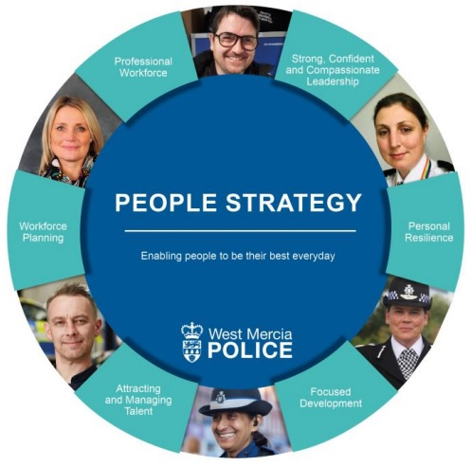

West Mercia Police seeks to develop and enable its leaders to achieve the best for themselves and their people, by recognising and nurturing talent for the future.

The force is committed to creating an inclusive environment where people feel empowered to exercise professional judgement, utilise their emotional intelligence and feel comfortable and confident to challenge. Ensuring people have the confidence and capability to deliver its vision and values by developing effective leadership qualities is pivotal. The force wants people to feel part of an organisational culture where they can be themselves, a culture that values diversity for the greater benefit of our communities.

The force also supports the National College of Policing leadership expectations which it endeavours to instil and develop at every level.

The police force invests in its people in a variety of ways which add value in order to develop a skilled, efficient and effective workforce that reflects the changing needs and demands of the police service.

Force vision and values are underpinned by a learning culture which embeds personal responsibility and continuous improvement in its people and the service it delivers.  
  
The force recognises that it is its people who will deliver the vision of protecting people from harm and therefore places significant emphasis on the health and wellbeing of its workforce. The force works to ensure that the workforce understands their role in maintaining a healthy and safe working environment to protect themselves, their colleagues and the public we all serve.

## Equality, Diversity and Inclusion

West Mercia Police serves approximately 1.3 million people. Promoting equality of opportunity and celebrating diversity is a fundamental enabler of the force’s overarching strategic approach. It is intrinsic to organisational culture, underpins objectives and helps shape the way in which services are designed and delivered.

The force is committed to serving its communities and people, taking into consideration and listening carefully to stakeholders.

### Statutory duty

The force must remain mindful of its duties under the Equality Act 2010 which is the UK’s discrimination law that protects individuals from unfair treatment and promotes a fairer and more equal society. The Act protects people from discrimination, harassment and victimisation in work, education and when accessing services.

In addition the Public Sector Equality Duty (PSED) came into force across Great Britain on 5 April 2011. It means that public bodies have to consider all individuals when carrying out their day-to-day work - in shaping policy, in delivering services and in relation to their own employees.

The force’s aim is to increase trust and confidence and its approach is to empower communities to actively participate in delivering a fair and accessible police service for all.

The force’s interim strategy on equality, diversity and inclusion is available to read on the West Mercia Police website.